English EiM 9H – Units 1-3

Reading
– Texts –

Text 1

The British school uniform

Millions of British children wear a uniform to go to school every day. Boys and girls have to wear them. Here is a list of the traditional school clothes.

- The jumper is usually in the school colours: black, grey or navy. Boys and girls usually wear the same jumper.

- Blazers are not practical in British weather. But in some schools, pupils have to wear them all year!

- School shirts are usually white and should be tucked in*. In some schools, you are punished if you wear your shirt out of your trousers!

- The tie is in the school colours. Usually girls and boys wear it. After school, the first thing that students do is take off their tie.

- Trousers must be elegant, black or grey. Some schools let girls wear trousers, but you’ll go back home if you come to school in jeans!

- In some schools skirts cannot be too short – 2 cm above the knee, for example.

- In some schools girls can wear tights with their skirts. But in more traditional schools girls have to wear the school socks!

- Students at strict schools wear black or brown shoes. Often ballet shoes can’t be used! Public schools are more relaxed about shoes and sometimes students can wear trainers.

- In strict schools, your school bag is the one thing you can choose for yourself. So it’s an important accessory!

Texte adapté du magazine I love English n°181, pp. 14-15
Text 2
Visit my English school!

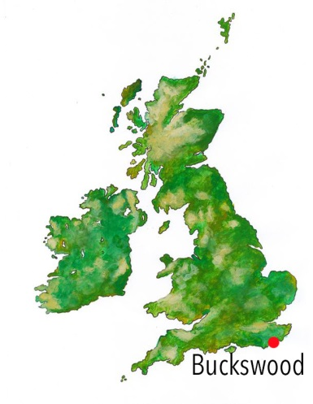
Guillaume is a French boy who now goes to Buckswood, an English boarding school with Harry Potter charm! He tells our magazine “I love English” that his life there is just... magic!

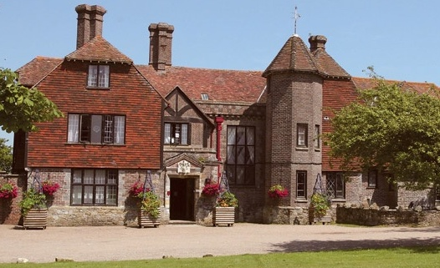
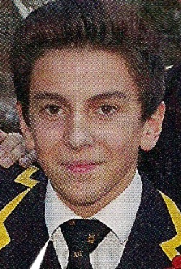

I’m Guillaume.
This is my 4th year at Buckswood.

Buckswood is not just an ordinary school – it’s a private boarding school* in the south of England. Students come to the school from all over the world. There are no lessons of magic, but the students enjoy many other ingredients of the Harry Potter lifestyle at the school!

1. “First of all, the school building looks very English. It is an old house, similar to Harry Potter’s school: Hogwarts! We also have prefects* and we live in different school houses – one of the houses is called “Rowling”, like the writer of the Harry Potter books!”

2. “At first, it can be hard. A lot of students miss their parents at the beginning. It’s even more difficult when you can’t speak a word of English and when you haven’t got a phone, like me! But after some weeks, it gets better. Now I’m great! It’s also easier because I learned* to speak English here.”

3. “I get up at seven o’clock and go to the dining hall at 7.30 am with the other students. There, we have breakfast in uniform! At 8.40 am, the headmaster* comes to check that our rooms are clean. I then spend 15 minutes with my tutor and I go to lessons at 9.05 am.”

4. “At school we have a mix of international cuisine and it’s very good! The meals are prepared by the school’s three chefs. We eat in the dining hall. Each table has a prefect who is the “head of the table”. The high prefects, the teachers and the headmasters sit at the high table, but we all eat the same meal. All the school sits down to eat together as a family.”

5. “I’m a boarder which means that I stay at school every day of the week. We have normal lessons on Saturday morning, and in the afternoon we can go to the town centre on the school bus. On Sunday I usually do sport and... my homework!”

6. “At school I like studying Maths, English, Sport and ICT, but I don’t really like Science. I enjoy languages: I study Spanish and Chinese. I love speaking a different language, especially Chinese!”

7. “After school I play hockey, basketball and rugby. Buckswood is doing really well in competitions against other schools, especially in football and hockey. I like going to Buckswood because the sport here is really good...”

8. “When I leave school, I want to be a businessman and travel around the world speaking lots of different languages. In each country I’ll have a place to stay – with each of my old friends from Buckswood!”

Texte adapté du magazine I love English n°215, pp. 12-15

* tucked in rentré, à l’intérieur
* boarding school internat
* prefects chefs de classe
* learned apprendre (au passé)
* headmaster directeur d’école ou proviseur

