Teacher’s note: Here are several activities linked to the movie. They are separate activities and are not meant to form a sequence. They need to be adapted to the age and language level of your students.

SHORT FILM : « The Present »

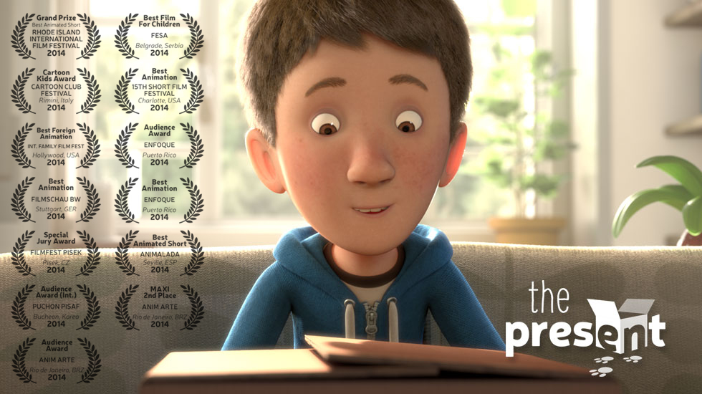

Pre-watching questions

1. Do you have pets?
2. What’s your routine at home after school or during free days?

At the beginning of the movie (show the film up to 2:41)

1. Make predictions about the present.
2. Watch the movie without sound and write the dialogue between the mother and her son.

After viewing

1. Rewrite the story using the simple past tense.
2. Draw comic strips of the story.
3. Retell the story with the mother or the boy point of view.
4. Open discussion about the emotions triggered by the story:
- Was the ending surprising?
- How does the movie make you feel?
- Can you describe the boy using positive and negative adjectives?
- Does the film have a message?

