Teaching English with movies

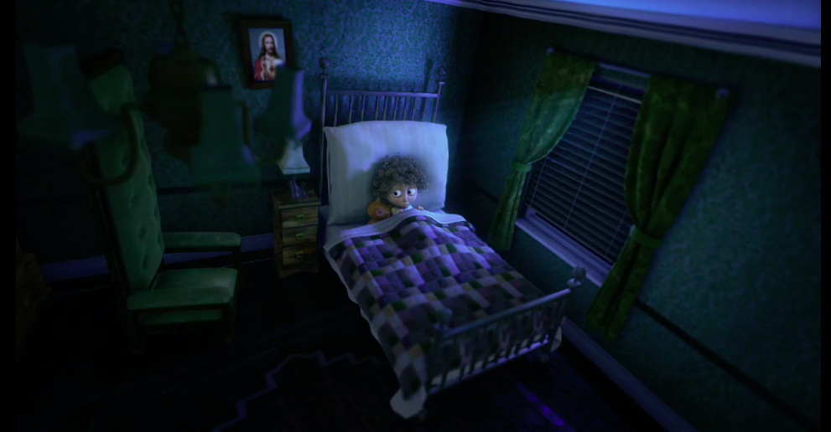
Granny O’Grimm’s Sleeping Beauty

Guideline:

1/ Before watching the movie, answer these questions:

- Do you know the tale (= le conte) Sleeping Beauty? What is it about?
- Do you know other traditional tales you read or heard about when you were a young child? Which was your favourite? Here are some words to help you find the titles in English.

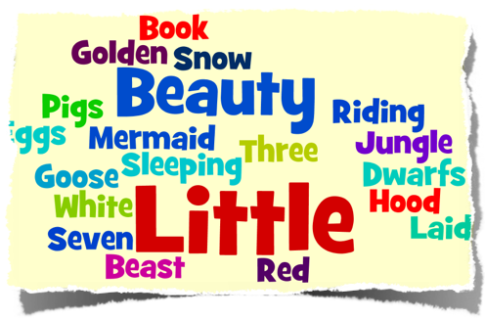

Answers:The Little Mermaid, Sleeping Beauty, The Jungle Book, Little Red Riding Hood, Beauty and the Beast, the Goose that Laid the Golden Egg, The Three Little Pigs, Snow White and the Seven Dwarfs

2/ Watch the movie and stop at 3’44 minutes: Here’s the link https://vimeo.com/7937986 and answer the questions:

- What’s the name of the young princess?

- Who is not invited to the christening (= le baptême) of the princess?

- Can you describe her?

- Draw this character here.

3/ Watch the end of the movie and read the transcript:

“Oh, I thought that you wouldn't want to be out and about with your knee giving you so much trouble”, said the queen.
“I thought you died months ago”, said one of the stupid young fairies.
Now you’d think the elderly fairy, being older and wiser, was able to forgive them. Don't be ridiculous! Of course, she wasn't! She loomed over the cradle in a menacing manner and laughed for a very long time! It was for longer then that!
Oh, look at you, aren’t you great with your smooth complexions and your social calendars dancing around on your working legs. You make me sick! You look at me and you find me so old and repulsive. Well, I've learned a thing or two in my time. Try this on for size! And with that, she put a terrible curse on the party that each and every one of them would die in the instant they ever fell asleep!

- Write the subtitles for this part of the movie in French! You can use a dictionary, any websites to translate it.
- Record your translation on vocaroo.com and upload the file to share with your classmates. You can vote on the best one (on Google form)
- What’s the differences between the tradition tale Sleeping Beauty and the movie?

