Révision English in Mind 11H : Unit 5

READING – “Richard Turere – an inventor”

PART 1: Read the text quickly and underline the correct answer.

What problem did Richard’s parents have on their farm?

A They have trouble finding people to look after their cows, goats and sheep.
B Lions aren’t afraid of people anymore and come too close to their farm.
C Lions attack their cattle.

PART 2: Read the text again. Write T (true), F (false).
1 Richard has always wanted to protect lions.
2 His invention is now used by other farmers.
3 Richard’s invention is very expensive.
4 Richard is an engineer.
5 The elephants are frightened by the lights.

PART 3: Complete the sentences with the correct words from the text.

1. All Richard’s inventions have been made from simple things and old ______________.

2. The lives of both the farm animals and the _____________ have been saved thanks to Richard’s invention.

3. Crops have been protected from ___________________ by Richard’s lion lights.

4. Richard has been given a place at a top high ___________ in Kenya.

PART 4: Find the words in the article for the following definitions.

1. pieces of electrical equipment, like washing machines and ovens, used in people’s houses. _________________
2. a place where old, unwanted things can be left, bought and sold.
_________________
3. a small electric light that you carry in your hand. _________________
4. animals that kill and eat other animals. _________________
5. someone who designs or builds things such as roads, railways, bridges or machines. _________________

READING TEXT
Richard Turere: an inventor
Richard Turere has always enjoyed making things using old household appliances and machines. For example, when he was quite young, he made fans for his parents’ house from car parts and things he found in a junkyard.

Richard lives on the edge of the Nairobi National Park in Kenya. The park is full of rhino, giraffe, buffalo and lions.
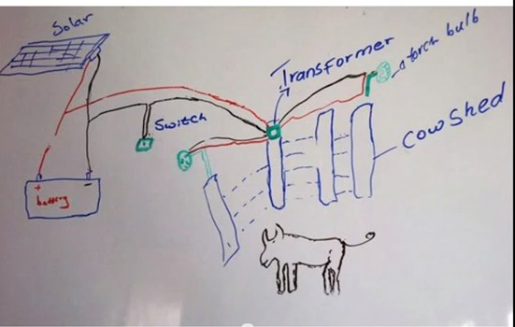
Since he was nine, Richard has had the job of looking after his family’s cows, goats and sheep. The big problem has been the lions. “I grew up hating lions,” says Richard. “They used to come at night and feed on our cattle when we were sleeping.”

This is Richard’s diagram showing how the lion lights work.

Then one night, as he was walking around with a torch, he noticed something. “I discovered that the lions were scared of the moving light.” Lions are naturally afraid of people. Richard realised that the lions linked the moving torchlight with people, so they stayed away. Using some bulbs and wires, Richard set up a series of flashing lights to give the impression that people were walking around the land where animals were kept. The lions didn’t come near. Soon other families were using his “lion lights”.

Richard’s lion lights cost just ten dollars to make. They have not only helped the farmers but also the lions. Many lions have been killed by farmers trying to protect their animals. Now, across Kenya, Richard’s idea has been adopted by farmers to protect their animals from predators and to protect their crops from elephants.

Richard has been offered a scholarship at one of Kenya’s top school. “One year ago, I was just a boy herding my father’s cows. Now I want to be an engineer and a pilot.”

WRITING

“You’ve just heard about Richard’s invention. Write a tweet (maximum 140 letters and spaces describing it to a friend.”

LISTENING

Watch the TED conference given by Richard in 2013.

PART 1: Where was Richard giving a conference?

A. in Kenya
B. in California
C. in England

PART 2: Tick all the different ideas Richard tried to scare the lions away.

Use a scarecrow
Sleep with the cows
Use fire
Use a loud radio
Use lights

PART 3: Number these events into order (1-5).

Richard got a scholarship in one of the best schools in Kenya.
Richard set up his invention.
The lions kill the livestock.
Seven homes are now equipped with Richard’s invention.
Richard grew up hating lions.

PART 4: Explain Richard’s invention with the help of the diagram he presented. Complete the sentences. (5)
1. Richard got an old car battery and a ____________ .
2. The ____________ _______ charges the battery.
3. The transformer makes the __________ flash.
4. The _________ face outside to trick the lions.
5. The lions thinks that somebody is walking around with a _________ .

PART 5: What was Richard’s big dream?

A. Become an aircraft engineer.
B. Save the lions.
C. Present a conference.

Adapted from Cambridge Global English Stage 8 Coursebook with Audio CD, Volume 8
https://www.ted.com/talks/richard_turere_a_peace_treaty_with_the_lions/up-next#t-368045

